Template – Custom Content with Video
The template named “Template – Custom Content with Video” is applicable to Anthology Student.

Purpose and Outcome
This template provides an anonymous form sequence and supporting workflow for the use of a video in a form. Videos can be used to give a campus tour or instructions for filling out complicated Financial Aid forms or anything similar.

Prerequisites
The template was built with Forms Builder using the applications listed below. The template is forward compatible with later versions of the listed applications.
Application | Compatibility Version
Forms Builder Designer and Renderer | Compatibility Matrix
Web Client for Anthology Student
Workflow Composer
Packages installed from Package Manager in Workflow Composer | Activities and Contracts (V2)  Contracts (V1)  Forms Builder Contracts  Note: Ensure that the Forms Builder Contracts package used in Workflow Composer is aligned with the version used in the Forms Builder. Additionally, confirm that both Activities and Contracts (V1) and Activities and Contracts (V2) packages in Workflow Composer match the versions used in the Student Web Client to avoid compatibility issues.  It depends on which product is being used, for example:  For CRM:  Activities And Contracts (CRM)  Forms Builder Contracts
Workflow Tracking Database | N/A
Staff STS | 3.3.x

Step 1: Download and Import the Template
- Download the template file to your environment (local drive or network location).
- Log into Forms Builder and select the Export/Import tile.
- Select the Import tab.
- Click Select exported file and navigate to the downloaded template file (xml).
- Click Import.
Note: Import may fail if same files name is already available in environment or overwrite option.

- Export/Import

The “Video Example” and “Default-Confirmation” forms will be imported.

Step 2: Upload a Video File
- Select the Custom Content tile in Forms Builder.
- Click Select custom content files and navigate to your video file (mp4) or drag and drop the mp4 file into the workspace. Once the file is uploaded, it will be listed in the grid.
- Custom Content

Step 3: In Form Designer…
- From the Forms slide out, select the Video Example form.
- Customize the form for your environment. Modify properties on fields/components to make them required, etc., or add/remove fields on the form.
- Fields and Components
The form example has two HTML components. Edit the instructional text in the first component. Specify the file name of your video in the second component.
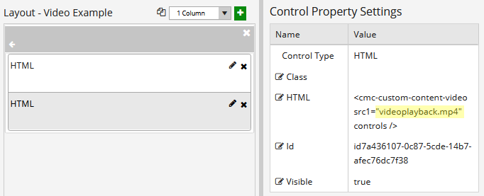
- Save the form.

Step 4: In Sequence Designer…
- Locate the Video Example sequence in the Sequences pane.
- Click Save As to create a copy of the sequence/workflow and customize the copy for your use. This way you can always refer to the original sequence/workflow you downloaded.
- (Optional) Customize the sequence properties for your environment.
- (Optional) Add a custom style (theme) for your campus.
- Themes
- Select your saved sequence in the Sequences pane.
- In the Properties Pane, as End State Form, select the imported “Default-Confirmation”.
- Save the sequence.

Step 5: In Workflow Composer…
You do not need to modify anything in the workflow.
- (Optional) Open the workflow for your saved sequence.
- Opening Workflows for Sequences
- (Optional) Explore the workflow to get an understanding of the workflow logic.
- State Machine Workflows

Step 6: In Forms Renderer…
Select your sequence and try it out!
- Sequence List
- Find your sequence and copy the URL to the clipboard.
- Paste the URL into a browser and complete the form sequence.

Step 6: Lastly…
Once your updated sequence has been tested successfully, it is recommended that you disable the workflow for the original Template version.
- In Workflow Composer, in the Server section of the ribbon, click Open.
- Find the workflow named Video Example.
- Clear the Enabled check box and click Save.

